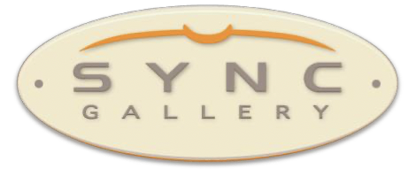

SYNC Gallery Contributing Artists Program
SYNC Gallery has an opportunity for artists living in or near Denver to develop and expand their connection to the Art District on Santa Fe, and advertise & exhibit their work through SYNC, an established gallery in the district. Participation in this program is open to any person aligned with the arts, including, but not limited to, visual artists working in 2-D and 3-D mediums, fine craft artists, and media artists.
We will be accepting up to 22 artists who work with 2-dimensional art and up to 5 artists who work with 3-dimensional art.
Fee: $150, payable annually by December 1 each year prior to the membership year. The program runs for the calendar year. Membership is renewable annually.
Contributing artists will sign a one-year contract with SYNC. Benefits for the artists as SYNC Contributing Artists:
- A space for 1 photograph and a contact link (to their website or e-mail) on a dedicated page of SYNC website.
- An annual exhibit with other Contributing Artists in the front half of SYNC Gallery. Each 2D artist will have 36 inches wall space. All expenses (including postcards, advertising, receptions, vinyl lettering) for this exhibit will be paid by SYNC. SYNC members will also be responsible for sitting the gallery during our business hours. (SYNC will ask a 30% commission on any works sold at this show)
- Special consideration should any artist wish to upgrade to Membership in SYNC Gallery. Interested artists should send name, email address, phone #, 5 images of their work, plus a short artist’s statement & short artist’s bio to:
- sjmarvinart@yahoo.com.
A committee of SYNC members will review all applicants and will select the artists.
Applications for 2024 need to be received no later than October 31, 2023, and applicants will know whether or not they are accepted no later than Nov. 30, 2023.

